LivingPrague.com  Trip Planner | An English Prague resident gives loads of insider knowledge and tips for all elements of your trip to the city. Time and money saving tips throughout.  Downloadable resources and personal recommendations to make your trip go smoothly from start to finish

The Livingprague.com trip planning guide

Contents
1 For people who want to be prepared 2
2 An area to stay 3
3 Hotel or Apartment 8
4 Arrival 10
5 Transfer 13
6 A place to eat 15
7 Exploring the city 18
8 Other things to do during the Day 22
9 Things to do in the evening and later 24
10 Souvenirs 26
11 Public Transport ……………………………………………………27

For people who want to be prepared
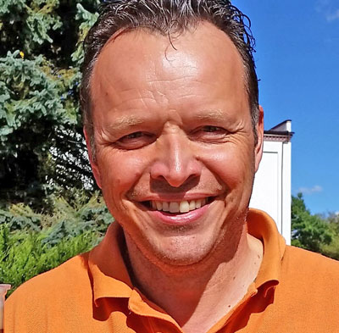
Congratulations to you for downloading this guide because it’s going to save you time and money. That handsome devil called Jason on the right is going to help you prepare for your trip. Who is it aimed at? Well, it’s aimed at anybody who wants to get ready for the trip and develop some confidence in visiting the Czech Republic possibly for the first time. This eBook links to both the Living Prague and LivingPragueTours webpages and utilizes all my experience of living and working in Prague since 1996 so in this guide you’ll learn about the following:

- How to choose the area to stay based on a few simple principles.
- Deciding on the type of accommodation and the pros and cons of each.
- Your food and drink options both fast/takeaway and sit-down/relaxing.
- Deciding if you want to use public transport and what’s involved in that.
- Your arrival in Prague whether by Plane, Train, Car or Bus.
- Dress codes and recommendations
- Transferring to and from your accommodation.
- The most popular attractions in the city.
- Tour options in the city.

So by the time you’ve got to the end of this planner you should have been able to:

Get the accommodation you want in the area you have selected, have a good idea about what you want to see in the city, where and what you want to eat and where you want to go for entertainment.
Did I miss anything?

In order to give you the best shot at enjoying yourselves in Prague I’ll be posing a few questions that will help you decide how to get the most out of your stay. Everybody wants something different out of the city so I’ll be spreading this quite widely. Some people like to get up early to see the sunrise, others like to see the sunrise BEFORE they go to bed.

I’m going to be naming specific places to go and activities to try because I’ve done all of them at one time or another. I’m going to explain certain misconceptions about the city and point out where those misconceptions could mean you get a good deal. I’m going to be inserting the odd piece of British sarcasm every now and again but I promise it will be fun and informative.

If this planner does not completely answer your questions then feel free to contact me.

An area to stay
If you are coming here on a flight/hotel package then this guide will help you understand where you will be. For others, usually you have booked your flights and now you want to find a nice place to stay. If you’ve done any kind of research for previous trips then you are probably sick of reading that all hotels are “Central” or “a short distance from the centre” having undoubtedly experienced staying in a hotel selling itself as “Central” when in fact it was not.
So, rest assured that if I recommend a place it is based on long experience and that it will match what you are looking for.
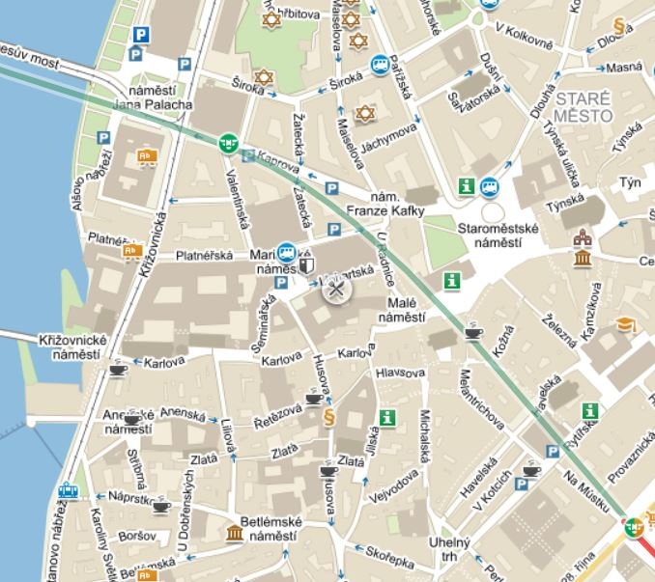
So what are the factors to be addressed?

- Accommodation type
- Hotel groups
- Basic Pricing
- Location
- Availability
- Public Transport

You want to stay central if you can so let me pose the first question. “What is Central Prague?”

Want to be Central?

My own personal definition of a “Central” hotel is one which at an average walking pace would take no more than 10 minutes to walk from the Hotel to either Wenceslas Square, the Old Town Square or the Charles Bridge.

Pro Tip: When checking accommodation photographs pay particular attention to places that do not show a picture of the front of the building or one that shows the building but not the pavement as these often indicate a main road in front of the hotel. Night pictures always make a place look nicer.
Pro Tip: Some hotels and apartments view a “double” as two singles pushed together. Hotel Perla has single beds with a locking mechanism but most places will not. If a “classic double” i.e. king size is important for you then be sure to check direct with the hotel. The alternative is what is called a “Marriage bed” where you have a single frame with 2 mattresses and 2 separate quilts.
Pro Tip: For drivers, when any Prague 1, Prague 2 or Prague 3 accommodation says “public parking” note that there is NO UNLIMITED TIME parking in these areas so either you will be using short-time bays or a public car park.
Tourism in the city is largely contained within the area known as “Prague 1” so then we must consider the central Prague districts and within those, the main areas where you’ll look to stay but maybe for different reasons. Click any banners or links to drop into the detailed webpage for that area:

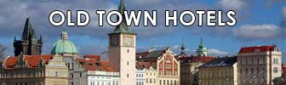
- Prague 1 Old Town (in Czech – Staré Město):
The geographic centre of the city.
It should be possible to walk between any two points in the Old Town in less than 10 minutes.
The Jewish Quarter (Josefov) is within the borders of the Old Town and is considered to be part of it. Pros: the tourist centre of Prague, pedestrianised areas, lots of bars and restaurants and most of the publicly accessible historic sites. Cons: most crowded, expensive and not many options for parking.

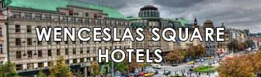
- Prague 1 New Town Wenceslas Square area (in Czech – Nové Město): This is the largest area with its furthest border about a 20 minute walk from the centre. Wenceslas Square and Republic Square are both in the New Town. There are a greater number of accommodation options and in most cases still less than a 15 minute walk to the Old Town. Pros: lots of restaurants, shops and night clubs, TWO metro stations, Můstek is on the Green “A” line and Muzeum is on the Red “C” line plus a tramline with a 24 hour service, 5 minute walk from the main train station.
- Cons: reputation for attracting stag parties at night, not so scenic.

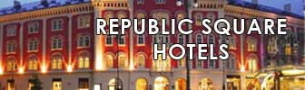
- Prague 1 New Town Republic Square area (in Czech – Náměstí Republiky): Republic Square is not going to be first on your list but it has a lot going for it. For a start you can walk from most of the area to the Old Town Square in less than 10 minutes. Prices are around 20% cheaper than the Old Town. This area traditionally opens its Christmas Market before the Old Town Square. The Municipal House is located here. Of the three main roads in the area “Na Porici” has hotels and shops, “Hybernska” has hotels and shops and “V Celnice” has restaurants and hotels. Pros: very close to the Old Town, pedestrianised areas, excellent tram/metro connections and the largest shopping centre in Prague. Cons: On the far side be aware that hotels Opera, Merkur and Grandior (extension) face the main highway. Hotels like “Hilton Old Town” or “Century Old Town” are not in the Old Town.

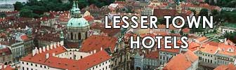
- Prague 1 Lesser Town and Kampa:
It’s called the Lesser Town because once upon a time the Castle area was considered the most important so the area under the Castle complex was “Lesser or lower”. As one of the oldest areas in the city it still contains a lot of official buildings and embassies so hotels in the area are spread out between the Malostranska metro station at one end and Kampa (riverside area) at the other with Nerudova going up the hill. Note that the high percentage of diplomatic Embassies and Consulates means a higher police activity. Pros: not attractive to Stag groups so it’s considered as quiet and has good options for scenic restaurants. Cons: Expect a 10% “Kampa tax” and heavily restricted parking.
- Prague Castle:
(in Czech – Hradčany):
The Castle area has the most official buildings and the least number of hotels. The hill leading up from the Lesser town contains most of the apartments whilst the bigger hotels (Questenberk, Lindner, Savoy) sit at the very top. This area also contains “Nový Svět”, a popular small street with many little old houses and the U Raka romantic hotel. Pros: without doubt it’s the quietest area in the city and the closest to both the castle and the bulk of the National Gallery locations. Cons: little to do in the area at night unless you go to a restaurant. The public transport service is limited to Tram 22 so expect to be walking or taking taxis.

Prepared to Walk a Little or use the Metro/Tram?

Prague 1 locations do account for the bulk of the hotel bookings in Prague purely because people want to stay central but, as I’ve gone to all this trouble to explain about all the different central areas I will now tell you how by just crossing a street you can save up to 30% on the cost of a hotel or apartment. It’s simply a question of knowing where the borders are. There is a huge premium put on an “Old Town”, “Wenceslas Square” or “Lesser Town” location by hotels but you are a savvy traveller so you want that central location but without the central prices.

If you are finding the Old Town, Wenceslas Square and even the Republic Square area are too expensive and you are prepared for a 15-30 minute walk or are prepared to use the metro/tram systems then consider the areas below.

I’m not sending you out in the woods ok so let’s say that you are prepared to take a 10 minute trip on Public Transport from the closest metro/tram stop to your hotel to either the Old Town, Wenceslas or Republic Square (that’s the equivalent of a 25 minute walk). What you have now done is opened up the options for the following areas:

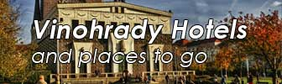
Vinohrady Prague 2. Here’s where the difference between Prague 1 and 2 is very noticeable. At the top of Wenceslas Square is the National Museum. Everything on the Square side is Prague 1 but everything behind the Museum is Prague 2 and this part of Prague 2 has a specific name called “Vinohrady”. You have just crossed the main road and though prices will be lower, Vinohrady has maintained a premium rate but anybody prepared for a 10 minute walk will find bargains and even more so if you are prepared to take public transport.

Karlin Prague 8. The area is served by two metro stations and a 24 hour tram service to either Wenceslas Square or Republic Square. The flood of 2005 did this place loads of favours, not least in moving a lot of people out and allowing for an upgrade of the whole area.
I worked in Karlin for two years and it’s deceptively quiet compared to the other side of the highway which is only a few hundred yards away. A nearby business centre keeps a steady flow of locals into the bars and restaurants during the week to be replaced by a mix of tourists and locals at the weekend. More and more development money is going into this area and bigger hotels are getting in early. Four tram stops to Republic Square or six to Wenceslas. Or from the far end of Karlin its 3 metro stops to Wenceslas Square. Pros: independent businesses, great transport connections. Cons: Not too much to do after 7pm.

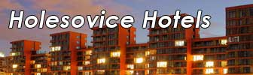
Holešovice Prague 7. The area is served by a train station, two metro stations and a 24 hour tram service to either Wenceslas Square, the Lesser Town or Anděl. It’s one of the more modern areas in the city and has a number of independent bars and restaurants. Most people visit here for the Rivertown market or the DOX exhibition centre.
From the far side of the area its maximum 7 tram stops or if you get on the metro station at Holešovice its 4 stops to the Wenceslas Square Muzeum station. Pros: lots of late opening bars/restaurants. Cons: realistically you’ll need to use the tram to get back and forth.

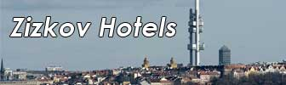
Žižkov Prague 3. This is on the other side of Vinohrady. Once again it’s an area that I worked in for a year. Lots of options for transport. On the Vinohrady side you have the main street Vinohradska with 3 metro stations in the vicinity plus 24 hour tram service. On the other side you have the tramline on Seifertova.
Žižkov is now catching up with Vinohrady as a trendy area. Bars and restaurants on most corners, a student population from the nearby faculty and the large park at Vítkov. Not great for driving as with popularity comes parking restrictions. Reasons for visiting this area include the Jiřiho z Poděbrad farmers market (video on Youtube at https://www.youtube.com/watch?v=1gcH7Q_DSmE) or the TV Tower. 4 tram stops or less to Wenceslas Square or if you are taking the metro its 3 stops to Wenceslas Square (Můstek) or 4 stops to the Old Town. Pros: Late opening bars and restaurants, great transport connections.. Cons: suffers from petty car crime.

Anděl and Ujezd Prague 5. Ujezd is a small area between Anděl and the Lesser Town and frequently I see places advertising themselves as in the more prestigious Lesser Town when in fact they are in this area. Ujezd has the river on one side and the Kinsky Gardens on the other. Architecture is 1900-1920 so solid stuff. Anděl is now the larger part and has a bus terminus, metro station and is a major tram hub for people wanting to go over to the new Town (Wenceslas Square).
The riverside buildings are quite old but most of the buildings behind the Staropramen brewery are modern. The centre of Anděl has the shopping centre and two cinemas. Pros: Entertainment hub, transport hub. Cons: Nothing particularly historic.

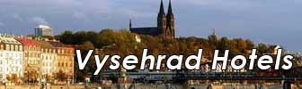
Vyšehrad Prague 4, there’s a big valley in Prague called Nusle and Vyšehrad is on the other side of it. At the highest point its 2 metro stops from Wenceslas Square or 8 tram stops. On the river side of Vyšehrad there are no metro stations but the river road tramline will get you to the Old Town in 6 stops. Vyšehrad has some excellent places buried out of view to most people but worth a look.
In the area you are most likely to be visiting the Vyšehrad church/cemetery or the river road, the “Žlute Lazne” recreation area or the Podoli swimming pool. Pros: off the beaten path, quiet and very residential. Cons: zero nightlife.

Hotel or Apartment
So we’ve established the area where you would like to stay. The section above will already have introduced you to available hotels in your budget but what about apartments.
Apartments
All different styles of apartments from lofts on Wenceslas Square to private rooms in apartment blocks so check my Guide to Prague Apartments both Central and non-Central
There is a large selection of apartments in the city. Most are self-contained so that means they have a kitchen or kitchenette and you are responsible for your own meals.
Things to look out for include:
- How do you get the key and/or return it?
- How many sets of keys do you get?
- Can the room temperature be individually controlled?
- Who do you call if you have any issues?
- Is anybody asking for a deposit?
- Are you charged additionally for utility use?
- Studio apartments may only have a fold-out bed.
- Modern Apartments may be ultra-functional but smaller and lacking in character.
- Classic apartments have bags of character and space but often the common areas and bathroom may disappoint.
- In general, apartment kitchens will use an electric hob on a timer switch.
- In older apartments the WC and bathroom are separated.
- Does the apartment have a lift?

Hotels – What to Look For
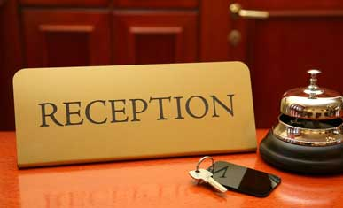
Pro Tip: The Czech style is to pay “per room per night”. Look out for apparently cheap prices as they may be “per person per night”.

This is all about the spec and the services.
The room spec (specification) would be expected to clarify the following:

- Size of room in sqm (square metres) including any bathroom.
- Technical equipment in the room (TV, media centre etc)
- Speciality features (anti-allergy etc)
- Air-conditioning individual/central
- Soundproofing
- Bed configuration

The hotel spec and services should confirm the following:

- Class by star rating
- Postal address
- Number of rooms
- Room types
- Reception hours
- Parking
- On-site restaurant(s)
- On-site paid services
- Business/conference services
- Pets

Wellness
If a hotel has any wellness facilities then the gym/jacuzzi part is normally free but you’ll pay extra for the sauna/pool. The exception is if the wellness area is treated as a separate business in which case you’ll get a guest rate and if you’re on a business package it’s likely to be free.

When is a Hotel not a Hotel?
Even with close to 700 hotels being available in the Prague area it’s not so easy to get “Hotel” status. Lots of hoops to go through, lots of regulations etc so how do you get around all that officialdom and still have paying guests? Well there are three ways. The easiest is to remain as a “Pension” or as we would call it in England, a guest house. But they can’t charge as much for the rooms.
Another way is to call yourself a “Residence” which is usually a step in the direction of eventually becoming a 4 star hotel. Residences (in Czech – Rezidence) cannot claim any star rating but you can usually tell from the photos and description that they are aiming at being a 4 star equivalent. If you see a “Rezidence” with a star rating it means that it is a Hotel but may be advertising itself as both Hotel and Rezidence having formerly NOT having been a hotel. Note that a Residence may not have a breakfast room in the building and may offer a “breakfast in the room” service or will direct you to an external café where they have a deal.
And finally when a hotel cannot call itself a hotel. You might not know but at the time of writing this you could not claim hotel status if you had dormitories in your building so places like Fusion and Mosaic House who offer hostel-type services as well as boutique accommodation will shortly be changing their business models to make sure they come under a 4 star rating.

Let’s not look too closely at any of the hotel descriptions. Suffice to say that I know the ones that stretch the truth a little too far. You’re welcome to contact me for any local knowledge I might be able to give.

Arrival
Your arrival in Prague will usually be by one of four means:
- Plane
- Train
- Car
- Bus

Note that I’ve now written a short guide to Prague Bag Storage Options.

Arrival by Plane:
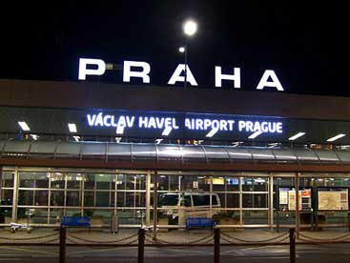
Did you know that in several books, Vaclav Havel (first president of the Czech Republic, a man who hated flying) was quoted as saying “I hope they don’t name the airport after me”……

The Václav Havel International Airport (PRG) is about 20km from the city centre. It has two main terminals called T1 and T2. If you are travelling FROM a Schengen country then you will be arriving at T2 so for more detailed info check the Prague Airport Terminal 2 (Schengen) Guide.

ALL other commercial passenger traffic including US and UK departures will land at T1 and you can read a lot more detail about that terminal in the Prague Airport Terminal 1 Guide. There are hardly any differences in the arrivals process with EU (Chip passport) automatic gates and dedicated EU booths at passport control so if you are not EU you’ll be heading for one of the “All Passports” booths. If you are transiting then there is a special transit gate between the “B” gates of T1 and the “C” gates of T2.

Just a note about departure though. T1 is older and has the x-ray machines at the gates. T2 is newer and has the x-ray machines directly after passport control. This means that T1 users can take bottles of drink into the departure area of the airport but users of T2 cannot. US air carriers have a strict security policy and you’ll need to allow extra time for check-in.

Details of Duty free shops at the airport and a video are on the Prague Airport Duty Free Guide.
Prague airport connects to the Public Transport Bus system. There is no tram or metro station. Transfers are explained in the next section.

Arrival by Train:

The three train stations that serve the city in order of importance are Hlavni Nadraži (main station), Holešovice and Masarykovo.

Main Train Station:
As a rule, the main station receives train traffic from Eastern Czech, Southern Czech, Western Czech, Austria, Hungary and the east of Germany (via Holešovice). It has several platforms and depending on where you were on the train you will exit either into the North gate of the South gate. They both arrive on the upper main concourse but have different facilities in the passages. The upper main concourse contains the toilets (you’ll need 1 euro or 20CZK) shops and cafes serving snacks. There are escalators on one side and travelators on the other to get to the lower main concourse which has the restaurants, bank/atm, transport ticket vendors, metro entry (red “C” line) and main station entry. The sub-ground floor contains a supermarket, the ticket offices and the luggage lockers.
If you need coins then the supervised toilets and the locker area have machines that take Czech banknotes and give change. The station is 200 metres from Wenceslas Square.
My Guide to the Prague Main Train Station gives additional details on the station, amenities, layout and nearby hotels.

Holešovice:
As a rule, Holešovice receives traffic from North East and North West Czech, Poland and Germany (Dresden, Leipzig, Berlin). Holešovice is much smaller with only 4 platforms and one common arrivals area from which you exit to the taxi stand or descend into the metro (red “C” line). Apart from newsagents and takeaway food vendors there’s not much else.

Masarykovo:
As a rule, Masarykovo it not an international arrivals station but it does connect with some services to Austria. It’s located about 300 metres from Republic Square and connects to the tram system. There is no metro access from the station itself so you must exit and use the entrance to the metro station “Naměsti Republiky”. There’s a casino, two small restaurants, post office and takeaway food/drink options.

Arrival by Car:
The Guide to Driving in Czech details all you need to know about driving here and links to my Park and Ride page.

If you cross the border into Czech then you may be considering using the motorway network. For this you WILL need a motorway sticker and the guide to driving in Czech describes how that works. Motorway services are well situated on the roads and so long as you fill up before you reach “Hlavni Město” then you won’t need to find additional services in the centre of town. If coming from Rozvadov then your last refuel services are on D5 junction 5 Rudna. If coming from Austria/Brno then the last easy services are at D1 junction 6 Průhonice although there is one more before you go into the centre which is smaller.

The “driving” page gives tips and advice about what to look out for in the city and outskirts, your rights in relation to trams and when you have to give way to pedestrians. You need to drive with your headlights ON at all times.

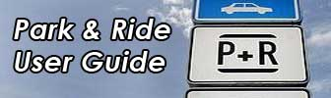
Parking in central Prague is controlled i.e. zoned “reserve” parking spaces indicated by a BLUE LINE around the bay. Metered parking is available in all central Prague areas but you’ll need small change. There are covered and open-air parking areas in the city and my advice for short-stay is to use a shopping centre car park like the Palladium. For a long weekend or maximum 7 days parking check the How to use the Prague Park and Ride page (with video of actual use).

Arrival by Bus:

There are two main Bus terminals in Prague. The biggest and most modern is at Florenc which connects to the tram system and also a metro junction between the red “C” line and the yellow “B” line which you access right outside the terminal. The main terminal building has restaurants and toilet/shower facilities. The main bus operators here are Eurolines and Student Agency.
The other terminal is in Anděl (Na Knizeci) and connects to the tramlines for the Lesser Town and New Town plus it has the Anděl metro station 250 metres away.

Transfer
We’ve got the desired area and you’ve got your hotel booked so next up is usually the transfer. For anything other than arrival at the airport you may need a short taxi trip or even be able to walk to your accommodation so this bit deals with Airport transfers which should take between 25 and 60 minutes to the centre depending on the type selected.
There are choices;

- Official Airport Taxi (can pick up FROM the airport without reservation)
- Private Airport Taxi (can only pick-up from the airport with a reservation)
- Public Transport by Bus (links to the nearest metro station Veleslavin)
- Private Transport by Bus (Airport Express to Republic Square and main station)
- Shared Shuttle (various companies)
- Liftago/Uber (can only drop-off at the airport)

I don’t assume that everybody wants a taxi nor that only young people take the bus. Any one of the above can be right for you so I’ll explain how they all work. I list all the options for transfer on the Airport Transfer Guide.

Private Airport Taxi:
Unless you’re on a tight budget then this is my recommended option. If you have a bad trip with an airport taxi you can only complain about an individual (if you remembered to note his name etc). With Private Airport Taxis you can complain about the company so I’ve found that these guys will bend over to provide a good service.

They are either the same price or possibly a bit cheaper, their basic cars are used for private transfers and are not city taxis. Plus if you are looking for that extra bit of style then they’ll offer upgrade options. I’ve worked with Prague Airport Transfers since 2014 (as they started in 2006 I decided to watch them for 8 years before recommending them!!)
You can read my 8 Reasons for Recommending Them.

Official Airport Taxi:
As you walk out of the arrivals lounge you’ll find the taxi rank. If you give the dispatcher the name of the hotel he’ll give you a price on the spot that the taxi will charge. The taxi will be AAA or RADIOTAXI and usually a bright yellow 4-door saloon. In general the driver will probably not speak English or may have a basic understanding. I hear the odd bad story but it’s pretty rare. The only issue would be after 10pm when the number of available taxis will reduce so sometimes I see people waiting for 10-15 minutes for the next taxi. Sometimes it’s a saloon and sometimes it’s a van.

Public Transport Bus:
The bus routes have now changed. Guides that are not up to date will still show the 119 bus going to Dejvice. In fact the 119 now goes to the metro station at Veleslavin. If you are staying around the Dejvice area and only carrying hand-luggage then you can get away with a 24CZK transport ticket (30 minutes). If you are staying anywhere else then you’ll need a 32CZK ticket (60 minutes). Bear in mind that a suitcase of large rucksack requires a luggage ticket (16CZK). You can read about the tickets and how to validate them on the Public Transport User Guide. Pros: it’s the cheapest option. Cons: you’ll need to get change at the airport or try and use the automated machine which is rumoured to accept credit cards out by the bus stop (big yellow box).

Private Transport Bus:
There is a private operator here called “Airport Express” (AE). You’ll need low denomination notes or correct change (driver gives change). The transfer includes one piece of large luggage. It’s more expensive than the public bus service but less expensive than the shuttle. It’s a point-to-point service from the airport to the main train station (on the way to the main station it will also stop at Republic Square) so if you are staying in the vicinity of Republic Square or Wenceslas Square it might be an option for you. In the bus rank queue at the “AE” pick-up stop (note that the drop-off point is NOT the same as the pick-up point). Pros: Comfortable and a good choice if you are the immediate Republic Square area. Cons: no direct transfer to hotel means you’ll have to know how to get from the drop-off to the hotel.
Here you can find Airport Express details in English.

Shared Shuttle:
The VW Transporter is the vehicle of choice for this transfer. It works out to be about 150CZK cheaper than the taxi transfers. You wait with the van until it has enough people to fill it (which is normally a minimum of 8). You then transfer to the centre and people will get off based on the location of the hotel. Be REALLY CLEAR with the shuttle dispatcher about the name and address of the hotel because if they drop you at the wrong place it’s an additional expense on you and an inconvenience to get to the correct place. Pros: Direct to hotel. Cons: May take twice the length of a taxi trip.

Train Station Transfers:
If you have arrived at either Hlavni Nadraži or Holešovice then you have the public transport option by metro. The Private taxi services will collect you from the station based on your arrival details and it’s usually 30% cheaper than an airport transfer. I DO NOT recommend using a taxi on the rank. If you’ve arrived at Hlavni Nadraži and you do not have a private taxi booked then exit the station from the main concourse adjacent to the metro entry, walk across the park to the Hotel Falkensteiner and ask them to call you a regular taxi.

A place to eat
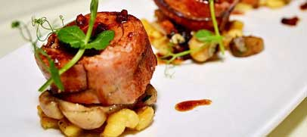
There are a lot of restaurants and cafes here suit all tastes but the average stay of a tourist in Prague is three nights so that’s around 8 meals, 3 of which will probably be breakfast at the hotel. So we have to make your remaining 5 meals something special. Special might be a scenic restaurant, some summer outdoor dining, a top restaurant in the city or a popular location. My advice is to do a bit of research to find places for your evening meal as you’ll probably take lunch if you see something you like as you are walking around during the day.
I make some of my own recommendations on my Guide to Prague Restaurants where I pick 30 or so of my favourites spread over a number of different cuisines but that’s only my own favourite places. Read my Cash or Card post for how best to pay for food and drink.
Restaurants:
Want to eat nice Czech Food and do a good deed at the same time? Then pay it forward. And if you want to experience the most popular Czech Food dishes then take a look at my Top Czech Food Picks.
Well let’s state the obvious and say that the pros would include comfort, privacy, service and cleanliness. For the cons it’s the price. Restaurants here are used to a standard 3-course meal and the only exception to that are tapas-style restaurants serving several small dishes at once or the top Italian restaurants in the city which maintain the Italian style.
There’s a common-sense dress code i.e. in the evening you’d aim for smart whereas in the same restaurant for lunch you’d get away with casual. In many restaurants they do not allow coats and jackets to be put on the backs of the chairs so if they offer a cloakroom service then make sure that you keep your valuables with you.
Specifically for Scenic Prague Restaurants I wrote an ebook detailing 23 places which could either be used for lunch or dinner all year round. Lots of pictures translations and descriptions. Its 2 euros.
Download the Scenic Prague Restaurants Guide.
Specifically for CZECH FOOD and CZECH BAR FOOD I wrote an ebook detailing 13 places where you can enjoy different types of Czech food in both restaurant and bar environments. Lots of pictures translations and descriptions. Its 2 euros.
Download the Enjoy Czech Food Guide
As you look around the menus you’ll find that some places offer a “degustation” which is a multi-course selection of the food that is served in the restaurant but served in smaller portions over a longer period of time.
A food-only Degustation meal would start at around CZK1500 and rise to CZK3000 in top restaurants. Include different wines and you can double that price. If you go for this then look out for the “Amuse Bouche” which will be a kind of Chef’s surprise that he/she really likes to make but which does not appear on the main menu. I personally had Balsamico ice cream in one place and it was fantastic.
I cannot think of any restaurants that do not accept credit cards but sometimes there’s an issue leaving a tip if you pay with plastic. Some places can only charge the billed price and you cannot add any extra so the only option is to leave a cash tip. For places that can accept the tip on the card then you get the remote card reader and it will ask if you want to leave a gratuity. Click yes to enter a value or click no to pay the charged price. Rounding the bill up to the closest CZK100 is accepted here otherwise a tip of between 5% and 10%.
The price you pay will vary but as a rough guide, the price you pay for dinner will be 50% more than what you paid for lunch.
Specifically for lunch, many restaurants offer the “denni menu” which is usually a two course lunch menu with smaller portion size than the same meal served for dinner. It’s considered to be the quickest meal served and also the cheapest.

Street Food:
Not everybody wants a big meal and the price of this type of food makes it attractive. On the main squares like Wenceslas and the Old Town you have fixed location cabins offering takeaway food all year long. You don’t have to take it very far as there will be high-tables in the vicinity (but no chairs). These fixed cabins will offer a choice of “fixed price” or “pay by weight” which applies to anything in a bowl or cooked on a spit. Read my pay-by-weight post to be prepared as this can significantly increase the cost of the meal. In a normal restaurant for a main meal you’d be eating a weight equivalent to between 200g to 300g so that’s what you’ll be offered but bear in mind that the price on the board is “per/100g”. So if you want this as a snack or light lunch then consider 100g to 200g.
The most popular “pay by weight” food is called “Halušky”. It’s Gnocchi and if it’s served in the classic style it will be mixed with either red or white cabbage and small pieces of smoked meat and on the side may be sour cream. Again this is a popular meal for the vendors to sell because it’s deceptively heavy and you don’t realise you’ll be paying double what you thought.

Hot dogs in the Czech style are served with mustard and a slice of bread but the vendor will offer the more recognisable “dog roll” where the sausage is in a roll. Most places will have all the mustard, ketchup and mayonnaise on a separate table for you to help yourself. Food-only price for a hotdog is usually between 60CZK and 75CZK. If you buy a menu i.e. with a 0.5L drink then it will be 100CZK to 115CZK. I’ve now published a Street Food post.

Takeaways:
Food “to go” is just as popular here as anywhere else. The Czech version is a “Lahůdky” which is a kind of deli/bakery which sells hot food for sit-down customers and open sandwiches (we call them Chlebičky). These open sandwiches will be between 15CZK and 30CZK. They’ll also sell filled croissants between 20CZK and 35CZK.
Burger King, McDonalds and KFC all work in the same way as you are used to with the exception that we call it a “menu” instead of a “meal”.
Wherever you find an area with bars then a takeaway pizzeria won’t be far away and if you go into the underground passages of many of the metro stations then you’ll find whole pizzas and “by the slice” being sold. A slice of pizza should cost no more than 35CZK but don’t expect the filling to be very deep.
Kebab shops have never really taken hold here as they have done in Germany but we do have them. I have two favourites in the Republic Square area. Eat-in or takeaway, the questions are the same “Doner or Durum”, “same meat or mix”, “chili or garlic sauce”. Expect to pay about 80CZK for a Doner and 90CZK for a Durum in the centre of town. It gets 10CZK cheaper as you go out further.
Asian food is normally a sit-down affair but specifically sushi is a popular take-out meal especially in the summer when people grab the food and head for the river and the parks. It’s by far the most expensive option at @100CZK for a small maki set rising to 500CZK for Nigiri and Tempura options.
What some people consider to be the healthy option. In 2012 I saw my first “Salad Restaurant”, now they are in every shopping centre and train station concourse and scattered throughout the city. Originally labelled as “secretary food” by my colleagues it has become augmented by fresh juices and takeaway fruit. Companies “Green Factory” and “Ugava” are the main players with a regular salad at @110CZK and a soup for 50CZK. Fresh juices start at 50CZK.
The most common takeaway by far is from the bakery. My own favourite is a company called Ječmínek but you’ll find other options close to any metro or tram stop. At the time of writing a “Pain au raisin” or “butter croissant” was 19CZK.

Exploring the city
Well you’ve not come here to stay in the hotel room the whole time right. People on a short break almost always have three places in mind to visit. They are the Old Town Square, the Jewish Quarter and Prague Castle. After that the mind goes blank so let me help you out with a few tips. Check the Prague by Month section for specific events going on during that month. Links in this section go to livingpraguetours.com.

Pro Tip: In general, plan visits to Jewish sites on Sundays as they’ll be closed on Saturdays (see note at the end). There is a version of the Jewish Museum Ticket that also gives you entry to the Old/New Synagogue but it costs more. NOTE: If you are Jewish then you can go into the Old/New Synagogue “Chabat” service on Saturdays (bring your passport).

You need to ask yourself the following:
- Do I want to pay and be part of a group being shown around?
- Do I want a private guide?
- Do I want to be shown around but NOT pay?
- Do I want to show myself around?

Scheduled Paid Tours

I run a selection of scheduled and private tours where many clients have kindly written Trip Advisor Reviews. I was awarded the Trip Advisor Certificate of Excellence this year. These are tours that you just go online, select a date/time and book. You receive an email confirmation, meeting point details and automated reminders. Remember, if you like a tour but it’s not on at the date/time that you want then contact me and I’ll see if I can move things around to suit you. Also check my Skip the Line – Tips and Tricks post.

Scheduled tours are 2 hours or 2.5 hours, Native English and limited to 6 people so it’s a small group and you can choose from the following:

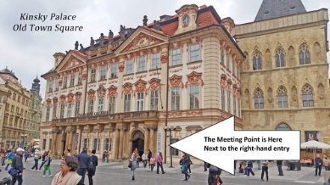
Old Town and Jewish Quarter Prague Walking Tour is the original tour on the site. We stay in the Old Town to explore that area and the Jewish area. Lots of top attractions, lots of fun stories, personal anecdotes and some “then and now” pictures. This should be your introduction to the city.

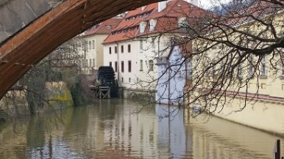
Prague City Walking Tour starts in the Old Town then goes via the New Town across the river to the Lesser Town and includes the public areas of Prague Castle. This is also my David Černy sculpture tour. A mix of history, culture and art. It’s a little more off the beaten path and for people who want to see different districts. Includes a tram trip up to the Castle and Imperial Gardens (Summer only for the garden).

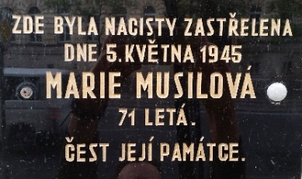
World War Two Prague is a tour of the New Town and Old Town including the Jewish Quarter but it concentrates on events relating directly to World War Two. All the main characters and events are described, memorials and plaques covering 1938 to 1945, from the Munich Agreement to the Prague Uprising.

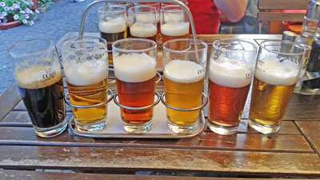
Czech Food and Beer Tasting is basically a shortened version of the Old Town and Jewish Quarter walking tour with the addition of food and drink. We stop in a couple of unique pubs during the walk and in the second pub you’ll have your choice of Classic Czech main courses and enjoy SIX different taster beers. It’s more expensive than a regular tour but bear in mind that it’s also going to be one of your meals.

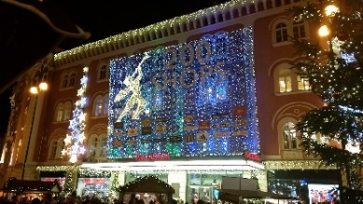
Christmas Markets is a tour of the 3 central markets including Wenceslas Square, Republic Square and the Old Town Square plus it includes part of the Old Town and the Jewish Quarter. Street food and drink is taken at Republic Square. It’s for people who want to explore the centre after dark, grab a hot drink and a snack and end up on the Old Town Square for the Christmas tree sound/light show. It runs from the first Monday in December up to the 22nd. There’s also a tour-only option.

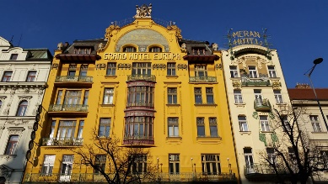
Prague Architecture is a tour that goes into why the city looks like it does, the influences on the city plus who designed and built much of the central area. It covers building types from 1344 to 1974 but tends to concentrate on the Avant-Garde period 1895 to 1930. It’s currently available only as a private tour.

You should experience the difference between navigating a city using a book and being shown around by a knowledgeable human

Private Guide
I offer all of the above tours privately. Alternatively you can choose your own duration i.e. make them from 2 to 8 hours etc and include specific things that you want to see. Just contact me with your request and I’ll quote a competitive price. We agree the requirement and I send you a secure booking link.

I don’t run river cruises but I do make some recommendations for a quick lunchtime trip to a 4 hour night cruise with music and dinner etc. Read about the options on the Prague River Cruise Review.

We have the phenomenon known as “Hop on, Hop off” (HOHO) and it works the same as in many other cities. You buy a pass for 48 hours and you can get on and off any number of buses during the day in order to get between the tourist sites. There are three circuits in the city.

Pro Tip: My advice is to hold off on a HOHO tour at least for the first day of your trip when you’ve had a chance to walk around and see how small the centre actually is. Then if you want to explore outside the centre you can use the Hop on bus to do that.

Free Tour
This third choice has probably got you thinking! Get shown around and then don’t pay? Can’t be right can it? Actually you really do a city tour albeit with somebody who may not have an outstanding depth of knowledge about the city and you may be walking around with a lot of people but it’s a smart piece of business in a few ways.
1) Halfway through the tour you’ll stop at a restaurant/café where you’ll be “encouraged” to buy something.
2) At the end of the FREE tour you’ll receive a request to leave a tip for the person who showed you around. Human nature would make it hard for us to walk away without paying anything so in general at least half of a group of 20-30 people will pay something.
3) You don’t need a business registration here if your income is a gratuity. So the operator gets round all the employment rules and still makes a profit.

It’s hit or miss and the business model relies largely on kick-backs. I’ve heard equal amounts of good things said as well as some real horrors. The problem with FREE tour reviews is that the review is usually not about the person who will be giving you the tour.

TOP Attractions

If you are using a guidebook to get your info then it will include a similar list of places to that on the TOP ATTRACTIONS GUIDE but, my page also gives you some inside tips and what to look out for in these places or a nice way to get to them etc plus a stellar list of other things to do in the city.

Possibly one of the cheaper options is just to get on a tram and ride around the city. A good example of this is the Number 17 which starts in Holešovice outside Stromovka park, cuts across the river and goes past the Old Town all the way down past the National Theatre, Slavonic Island and Dancing House plus you have the views back over the river across to Kampa and up to Petrin Park. Just about the best value trip for 2 euros you can get (approximately 1 euro there and one euro back).

If you are intent on really planning your trip to the point of know where you want to go and how long you want to stay for and this includes paid attractions then it will be worth you buying a Prague City Card. It’s set up for adults or children for either a 2, 3 or 4 day trip.

I tested this out years ago and you can get your money back in a day if you plan even a few things. Pro Tip: don’t just look at the locations, also check the opening and closing times to fit more in if you want to. The Jewish Museum pass is included on the card but remember that you’ll want to spend at least half a day in that area. Likewise for the Prague Castle. You can read about it at my Prague City Tourist Card Guide. If you want to buy one of these then go to the Tourist Information centre at the Old Town Hall.

Make your first stop the Tourist Info Centre on the Old Town Square. Even if you are not buying a Prague Card they do a good tourist map with easy to follow directions for you to visit the most popular places.

It’s now possible to buy the Town Hall Pass which gives you a visit to the New Town Hall and two visits to the Old Town Hall which is one entry to the museum/tower during the day and another visit to the tower after dark. If you want to see the procession you can find that on the Astronomical Clock Striking 9am video (watch out for the cockerel).

Other things to do during the Day
Make sure to check the Prague by Month section which I keep updated with bits and pieces that look interesting. I’ll assume that you will not be leaving the hotel until after breakfast so at a pinch we’ll call that 10am. Things to note are that at this time all cafes will be open, all public transport is running, all museums are open (Jewish sites closed on Saturdays) but not the theatres or cinemas. Most shops will be open, most restaurants and bars will NOT be open until at least 11am or later.

If you are looking to tour the city then I’ve already shown you my walking tours offer. But also consider touring the city in different ways. You’ll find several of my recommendations and what to expect on the Prague Bike Tours, Prague Segway Tours and Prague eScooter Tours pages. Or for other activities see what Get Your Guide here in Prague has to offer.

Prague is no stranger to the regular cycle of shops closing either to relocate or simply because they went bust. Whereas in the UK this would result in a Charity shop or a betting shop appearing, in Prague they do a very good job of making use of the space. We have many dedicated exhibiting shops and spaces for private individuals but the “pop-ups” cannot be planned for and nobody will list them in printed material. So the first you’ll know of a place like this is when you walk past it. It’s unlikely to be selling anything. More likely to be a venue for showing some kind of art and giving out business cards for later contact. Examples of these types of place include people displaying photographic media, graphic art, painted works, sculptures and even performers.

The street artists and performers are almost always to be found on the Royal Road (it links Republic Square with Prague Castle) or the other big squares like Wenceslas or Republic Square. These guys can perform or in some cases just sit there (an example is at https://www.youtube.com/watch?v=ExD5MjpPBJI) and the object is to get you to put money in their hat or box. Specifically for street performers who do not have a licence then they can play but they cannot sell anything so you’ll see that whenever the police are around the shut the box with the CDs

City supported events are normally to be found either in the open air i.e. the squares or the parks and usually involve large boards with pictures which can be entertaining and/or informative. They also support art being shown in the passages i.e. Lucerna is a favourite location for this type of art.

If you can’t get tickets to an evening theatre performance then consider a matinee. The page at https://livingprague.com/prague-entertainment/prague-culture/ will have links to places where you can look for afternoon performance times. The Estates Theatre regularly does Don Giovanni in the afternoon.

In many parts of the city you’ll be looking up at buildings that are 4 or 5 floors high but what you might not notice is that some of them have passageways that lead to small parks or courtyards. Locals will use them as cut-throughs so if you see somebody walk into one of these alleyways in a determined manner then chances are it leads somewhere.

Again, little noticed parts of Prague are the rooftops. Several of these places have scenic cafes and restaurants where the public can go. On Wenceslas Square you have Duplex, the Old Town Square has U Prince (Black Angels bar), Kotva department store has T-Anker on the roof, Lesser Town has Coda etc etc. Always be on the lookout for a hole in the wall and a lift at the end.

By 11am the restaurants will start opening and by 2pm most of the regular bars, shops and cinemas will be open.

Trips and Excursions
For the first time visitor here for 3 days or more or somebody that’s been to Prague before I usually point people to three places:

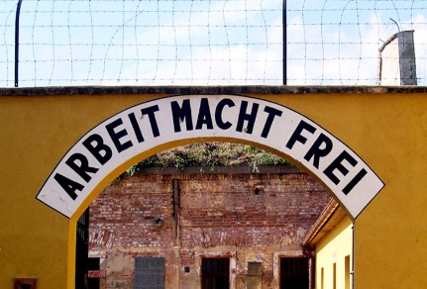
Terezin. Terezin was the “Model” Jewish Ghetto in the second world war. It’s not a death camp but many died there. It’s a nice half-day trip for people wishing to understand more about wartime Jewish life.

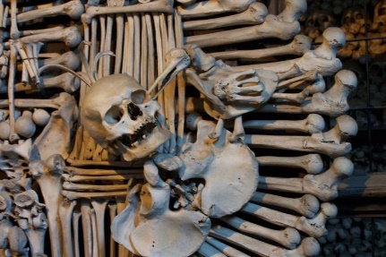
Kutna Hora. People will usually know it as the place with the bone church. On the post I give you organised tour options and tips if you want to travel by yourself and do it either as a half-day or a whole day as you also have the Mint and ST Barbara’s Cathedral.

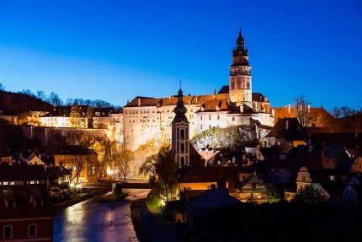
Cesky Krumlov. Probably the most scenic town outside of Prague and very popular in the summer (especially the 5 Petal festival in June). Again on the post I point out organised options and self-guide transport options. As it’s a 3 hour trip just to get there you are looking at either a 10 hour trip which includes lunch and a guided tour or an overnight stay.

Things to do in the evening and later
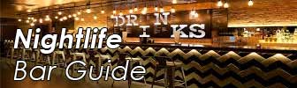
In Prague “evening” is after 6pm when your start hearing Czechs say to each other “Dobrý Večer” i.e. good evening! Between Spring and Autumn you’ve still got the tour options mentioned earlier.

In the summertime it’s still light and many of the attractions will be open for another hour or so but in winter it’s already dark and most of the main tourist places have closed or will be closing shortly.

Restaurants we went through earlier so this section is divided into three:

- Bars
- Music Clubs
- Culture

By Bars I mean regular bars which may have some kind of theme so it opens around 11am and closes around 1am but there are exceptions like Bar and Books which opens at 5pm and closes late. I list all my personal favourites on The Prague Bar Guide. That page is sectioned to give you a better idea of what to expect for different genres.

By Music clubs I mean places that will not open before 7pm and will close around 5am. Most of these places are listed on The Prague Nightlife Guide where I also show you some local resources for a more in-depth search of the Prague music scene.

Examples of smarter “walk-in” music clubs/lounges could be the Hangar bar or M1 Lounge. Full-on dance club like Karlovy Lazne, Lavka and Zlaty Strom are all within 100 metres of each other. Nebe has three locations in the city.

Also look out for themed events i.e. Dance Union in Vinohradska has one of the biggest hip-hop dance events on a Saturday and the biggest Latino dance night on Wednesdays. Jazz clubs have their own page on The Prague Jazz Club Guide where I list a good selection of places with different jazz genres and also a selected list of bands to look out for. The jazz clubs open late in the afternoon and usually the last set will finish between midnight and 1am.

Summer on the river is very nice so if you are a Jazz fan you’ve got the Jazz Boat which is a 4 hour evening cruise with food but the food is optional in which case you should eat first but make sure you are at the boat dock BEFORE departure time as there is no refund if you miss the boat.

On the Guide to Prague Performance Culture I list all the different kinds of performances available in the main 5 theatres here and any dress code applicable. You’ll soon see that Ballet is most often performed at the National Theatre but if you want a concise version with only the popular bits then the Hybernska theatre would be your choice. Likewise if you want modern dance and performance you’d go straight to the Laterna Magika. I also post details of smaller private performances in some pretty spectacular venues and combined dinner/recital events.

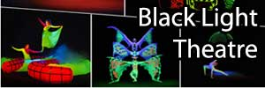
On the Guide to Black Light Theatre I describe what Black Light performances are like, where best to sit in the hall and links to the best Black Light locations. Black Light performance are usually finished by 9pm so you’ve easily got enough time to see one of these, eat afterwards and still have time for a club later.

Souvenirs
You don’t want to be weighed down with souvenirs of your stay or gifts for friends etc but consider the following:
Jewellery and Crystal – If you’re in the market for Bohemian Garnet or Diamond Garnet (that a mix of both) or gold or crystal then PRINT THE DISCOUNT VOUCHER for up to 21% off listed prices. To be clear that’s MINIMUM 10% for EU residents and MINIMUM 21% for Non-EU residents. You can use it on any product at the shop. The shop is in the Old Town and the google map location is at https://goo.gl/maps/dKorzwh4sPQ2

For Kids – We have a famous character here called Krtek which is Czech for “Mole”. In any toy shop you’ll find him in various sizes and in bigger book shops you’ll find his adventures translated into English.

For All – Marionettes are popular in Czech as they were always seen as the poor person’s theatre. You can get them in various sizes, materials and quality. My favourite over the years has been “Michael’s” at Jilska 22 in the Old Town. Great talking point using a famous Czech marionette character as a house decoration but if you give them to kids be prepared to spend long hours undoing the knots………

For Adults – During your stay you may have had the chance to try an aperitif called “Becherovka”. If you tried it neat then it’s a shock but take a bottle back with you and next time you try it add a thick fruit juice like pear or apricot. Fantastic (in the winter version you heat the juice).

Beer Glass – You’ve tried the beer now take home a glass. You’ll find that glass/crystal/souvenir shops will have a couple of shelves of metric beer glasses so if you liked your Pilsner/Gambrinus/Kozel/Staropramen beer, then relive your visit to Prague in your own home.

Garnet – I wrote about the Bohemian Garnet a long time before I found a place that I was sure actually sold it. If you know somebody with a January birthday then Garnet is their birthstone. The page at https://livingprague.com/prague-life/bohemian-garnet-prague/ shows you how to spot the real thing, a recommended place to buy it and discount options from 10% off for EU Nationals to 21% off i.e. tax-free for non-EU Nationals.

Miniature buildings – I had not seen this before I came to Prague but then having worked all over Europe I found that many cities have them. Basically they are miniature copies no more than 10cm high of buildings, often famous structures but others not so well-known and are often swapped between collectors.

Public Transport
Prague has a very efficient public transport system so here’s a few tips on how to use it.
First read the Guide to Prague Public Transport. This covers single use tickets and passes issued under the Prague Travel Card (Litacka) system. If you need anything more complicated than that then you need to go to a DPP office. In that case check the List of DPP Offices in Prague but note what they call the “scope of services” because not all offices do the paper/coupon part.

Anybody aged 59 or less will be using the guide above but once you hit 60 there are other options for example discounted single ticket rates and 30 day passes etc. Also if you are 70 or over then you qualify for free transport. You just need to go to one of the DPP offices listed above which does “The sale of PIT cards and of paper coupons with an optional commencement date of their validity”. You prove your age and they’ll give you the necessary card.

Note that the modern ticket machines sell tickets and passes up to 72 hours duration but you’ll need to pay with a credit/debit card which as “tap and pay” or “chip and PIN” or coins (for some strange reason they do not accept banknotes).

On the Guide to Public Transport I mention the 30 minute decision i.e. if you think your journey can be completed within 30 minutes then you can buy a CZK24 tickets. If you are not sure then buy the more expensive CZK32 ticket. Passes are valid for either 24 hours or 72 hours from the time that you validate (stamp them the first time you use the transport network).

Note that tickets seem to show different validity times where you see 30/60 mins or 60/90 mins then you will be on the lower limit during your stay unless you are really on the outskirts of the city. Just so you know, the CZK24 ticket shows 30 and 60. It just means that while you are within the central Prague (P+0) area then you get 30 minutes. Only if your journey ends somewhere in the “B” area. If you are outside the centre and you want to know if you are in the “B” zone then check the Prague PIT Fare Zones document.

So that’s it, hopefully you’ve used this guide and the websites to find good accommodation, nice places to eat, some attractions, things to do and places to go for entertainment in the evening.

You can always contact me at fun@livingprague.com and I help where I can.

